Creating a client-username and ACL profile and changing configuration of acl-profile

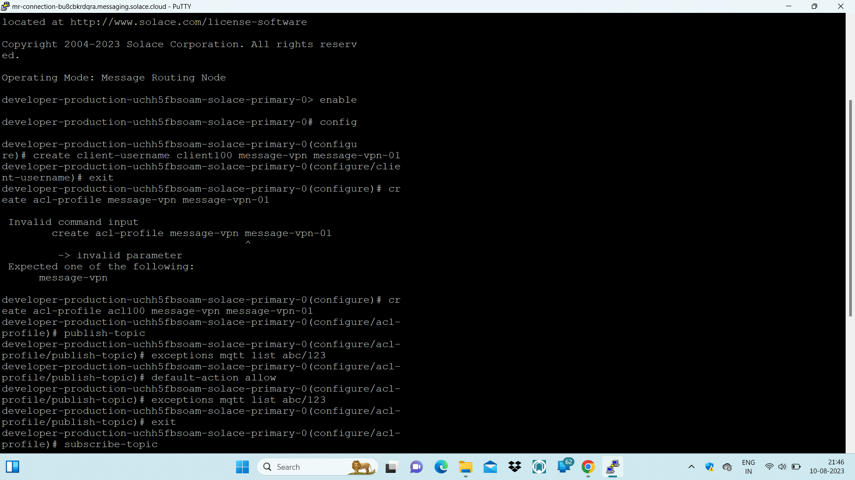

Client-username is created 🡪client100

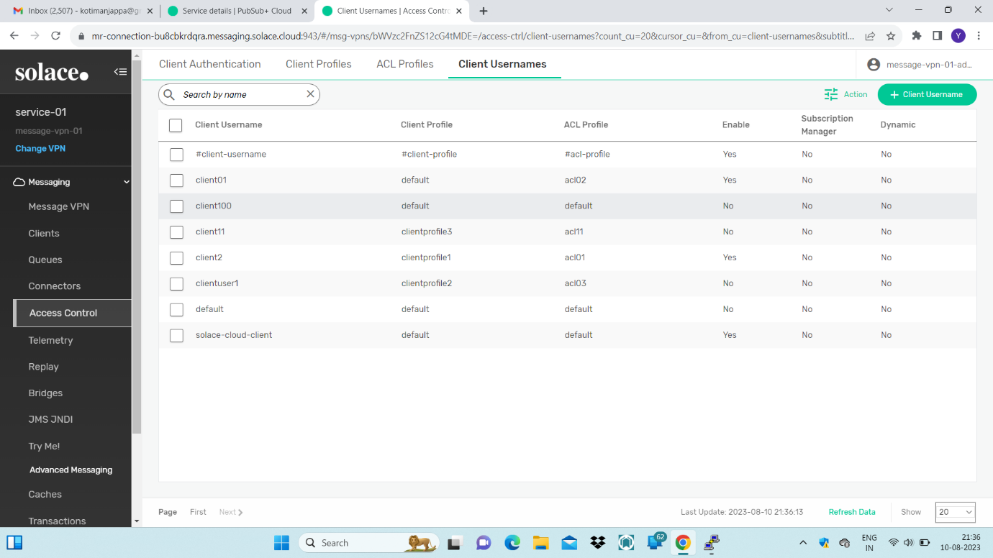

These are the configuration before changing settings using cli

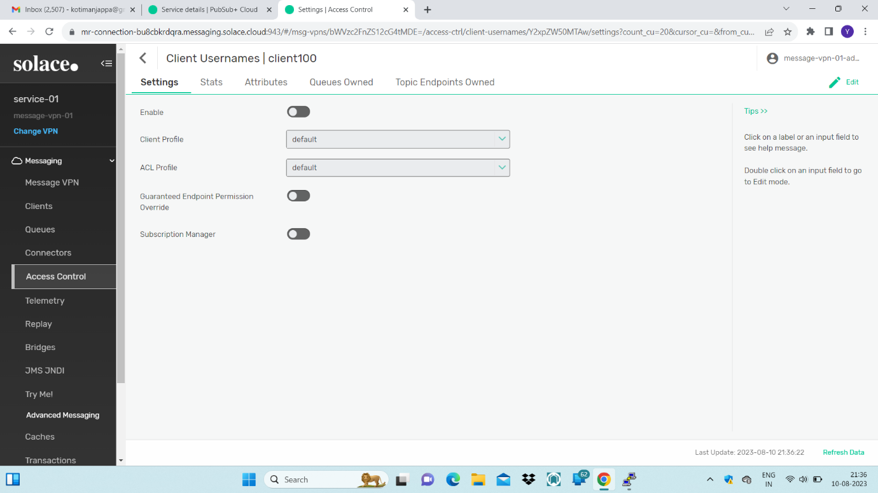

Acl-profile is created ,the commands are shown in first snap.

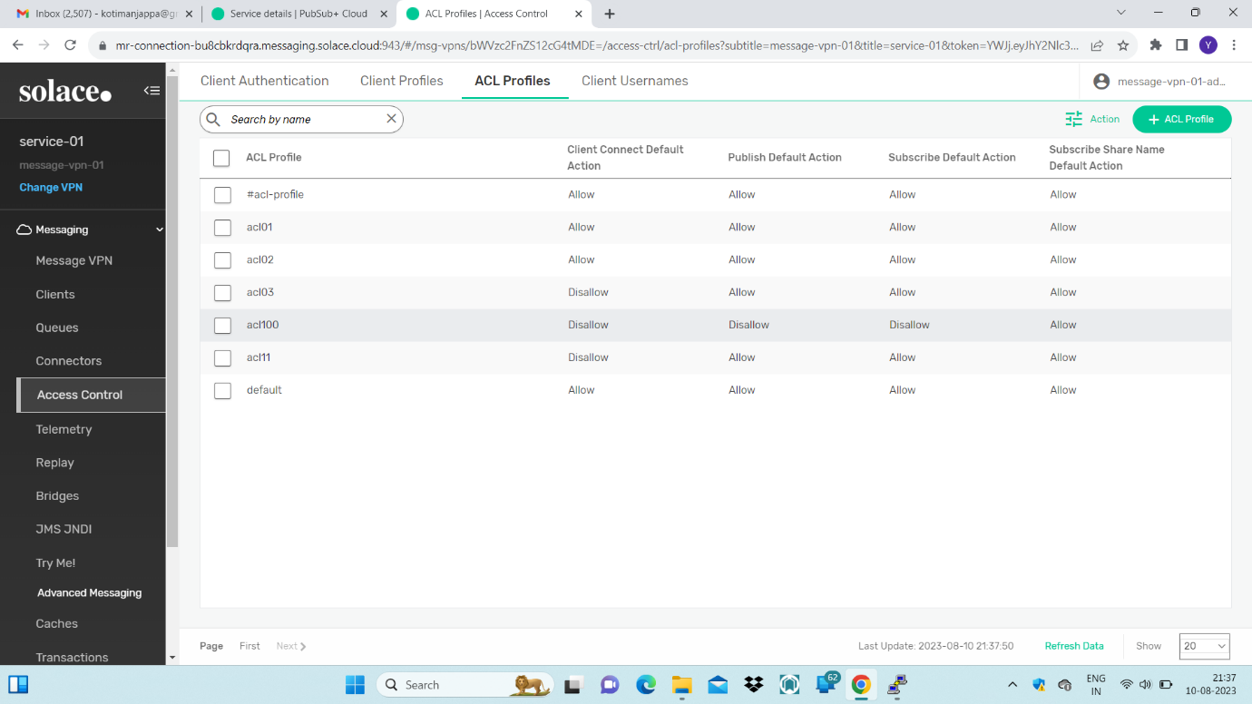

Publish default action made allow using command and exception is also added and the syntax of that exception made as MQTT.

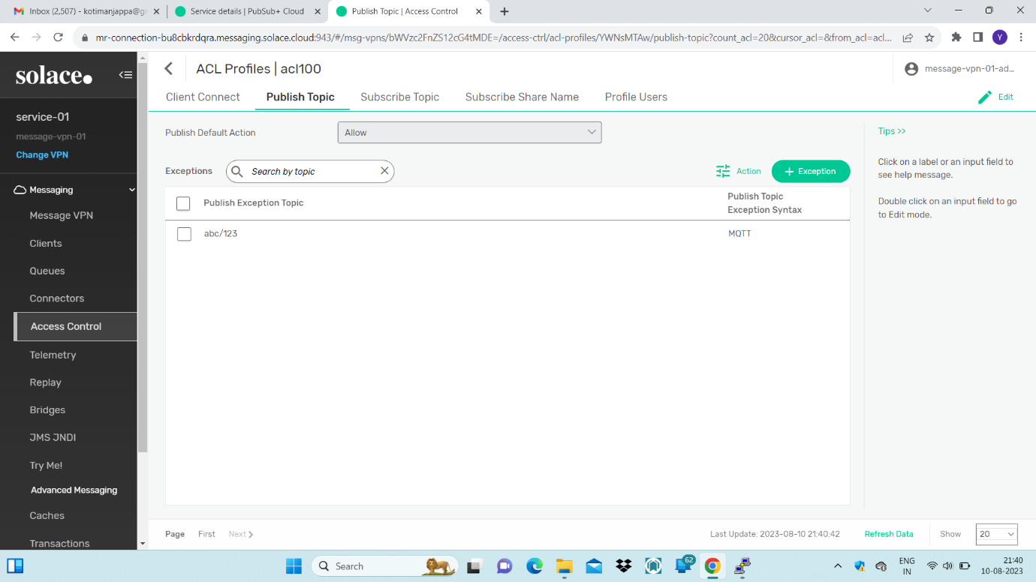

Subscribe default action made allow and exception added with MQTT Syntax

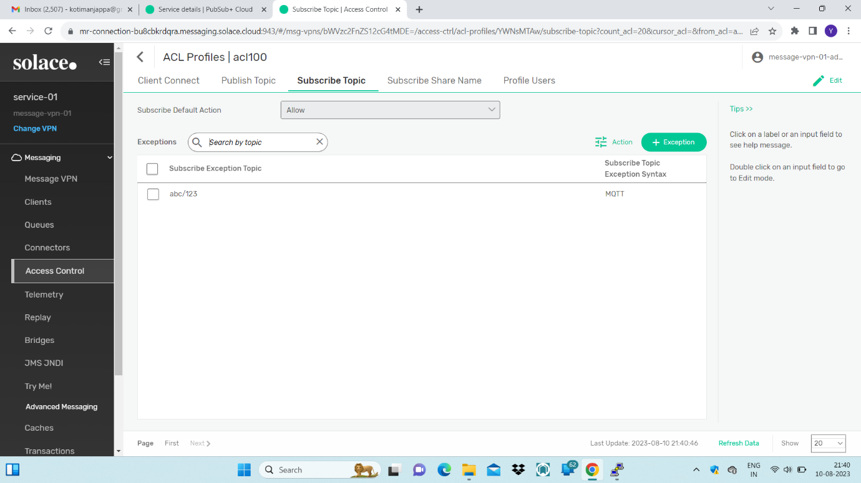

We will not be able to create Client-profile from cli ,so to create we click on client profile in

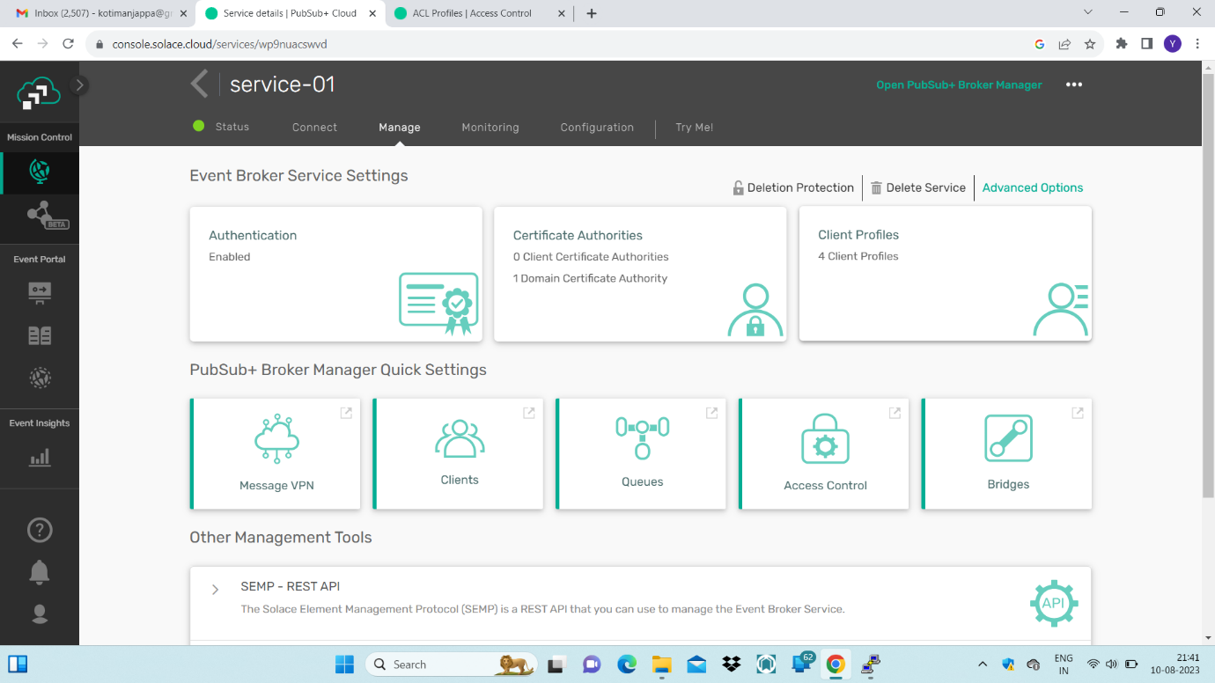

To add new client-profile click on add new

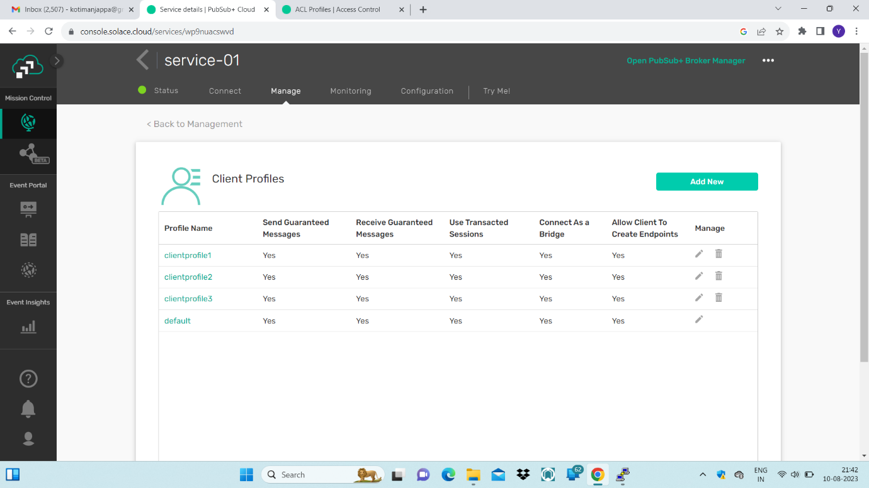

Give the name and change the settings according to requirement

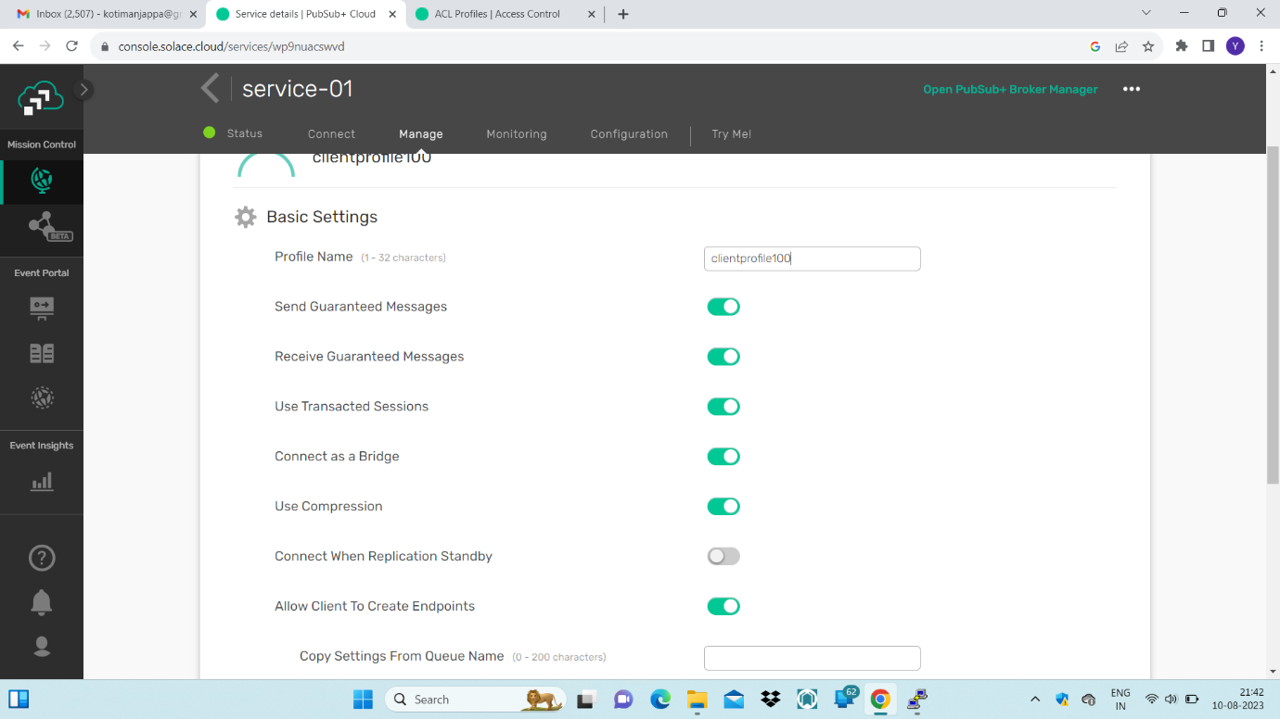

After changing click on save

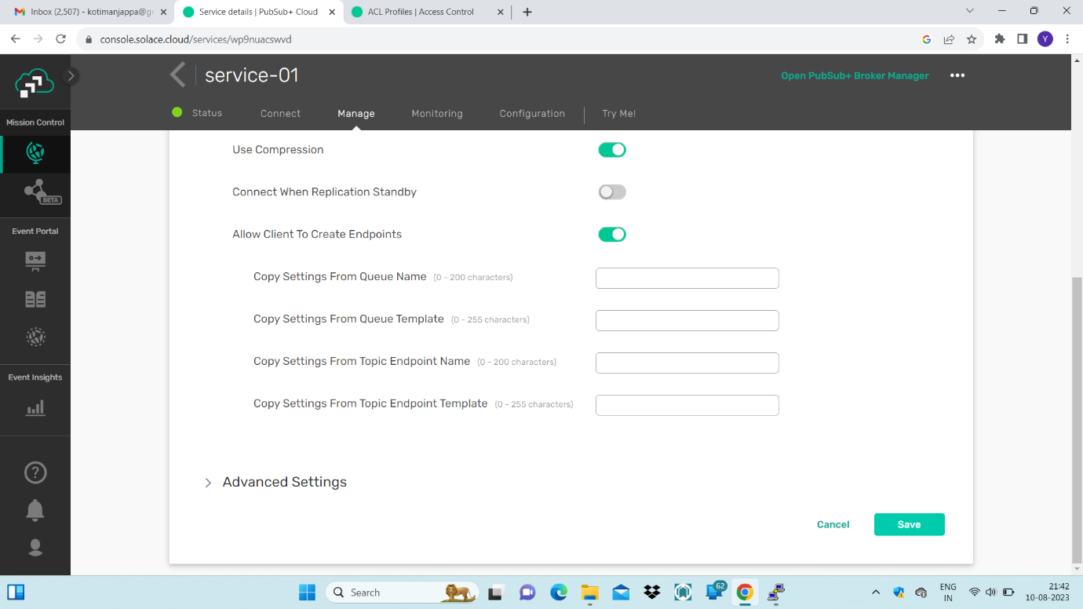

Client-profile is created

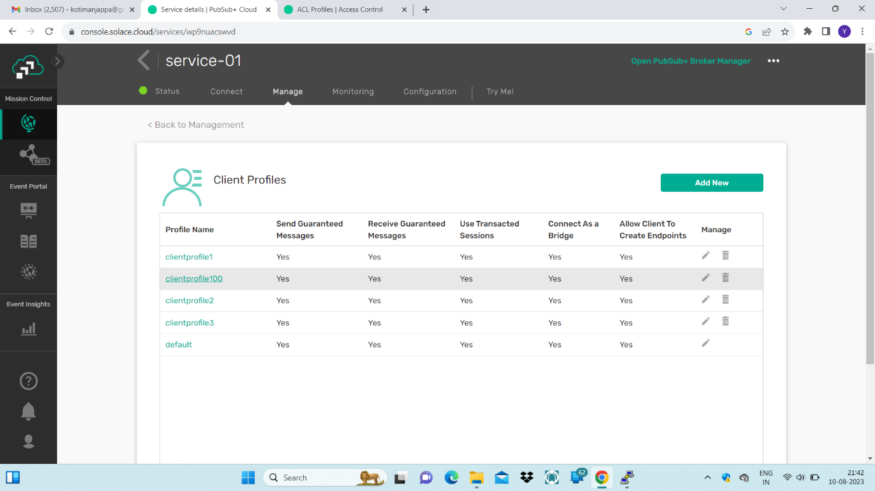

Client-username configuration can be changed

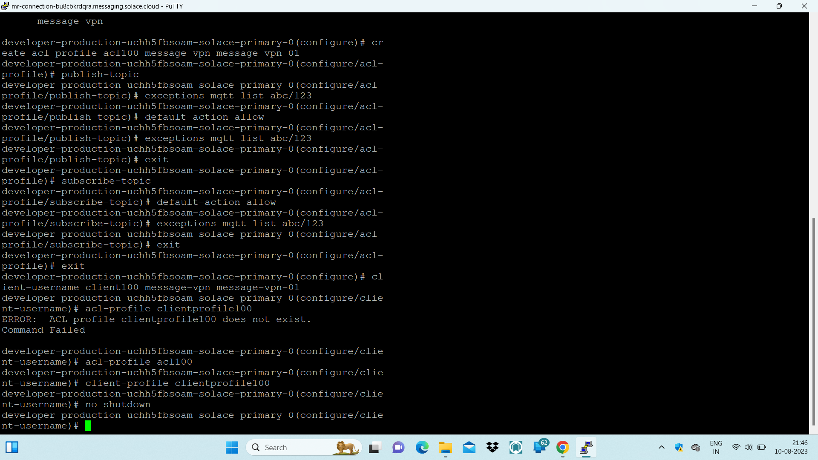

The configuration client-profile and acl-profile is changed/updated

